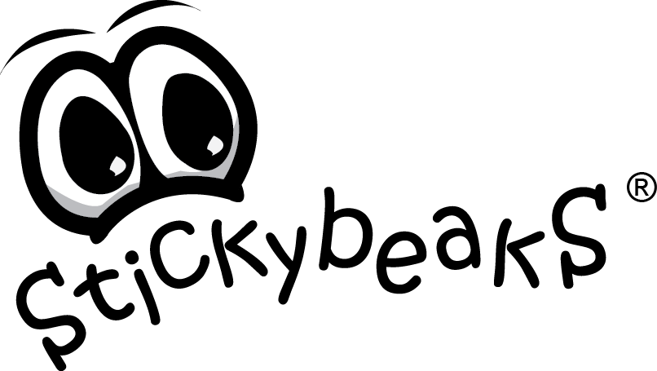
STUDENT ORDER FORM

Please select from the product guide below, simply write the quantity of each item you would like to order, then the $ amount for that item. Please tally total amount at the bottom of the page.

Oldest Childs Name: | Class:
Lunch Wallets | Price | Qty | Amount | Hard Top  Pencil Cases | Price | Qty | Amount
Black / Blue Binding |  |  | $ | Black / Red Zipper |  |  | $
Black / Pink Binding |  |  | $ | Blue / Black Zipper |  |  | $
Black / Green Binding |  |  | $ | Pink / Blue Zipper |  |  | $
Black / Red Binding |  |  | $ | Purple / Pink Zipper |  |  | $
Black / Yellow Binding |  |  | $ | Neoprene Pencil Cases
Black / Grey Binding |  |  | $ | Pink / Purple
Black / Purple Binding |  |  | $ | Blue / Green
Black / Orange Binding Allergy Alert Bag |  |  | $ | Snazzy Bags | Price | Qty | Amount
Insulated  All Rounders | Price | Qty | Amount | Young Girl |  |  | $
Black / Grey Binding |  |  | $ | Older Girl |  |  | $
Black / Blue Binding |  |  | $ | Young Boy |  |  | $
Black / Red Binding |  |  | $ | Older Boy |  |  | $
Pencils | Price | Qty | Amount | Black |  |  | $
18 Coloured Pencils |  |  | $
TOTAL AMOUNT DUE | $

Please support our school and your children by placing your order today!!

Final orders are due by
Return this Order Form, and payment in an envelope marked ‘Stickybeaks Order’.

If you would like further information about any of the products or to print off your
FREE name/class and order tags, please visit www.stickybeaks.com.au

Payment (please circle): CASH CHEQUE OTHER

Please make cheques payable to:

